

Build for multiple devices

# Overview

Phones and tablets are now so common in the workplace that developers simply can’t afford to ignore them. Modern line-of-business systems have to be able to reach users on their terms. Fortunately, Microsoft’s developer platform provides everything developers need to quickly and efficiently bring their line-of-business services to devices of all shapes and sizes.

If you have never built a Windows Store or Windows Phone app, Exercise 1 of this lab will serve as an introduction. You will build the same app twice, once as a Windows Store app and then again as a Windows Phone app. You will then move common code into a portable class library.

# Objectives

In this hands-on lab, you will learn how to:

* Build Windows Store and Windows Phone apps
* Create and use portable class libraries

# Prerequisites

The following is required to complete this hands-on lab:

* Microsoft Visual Studio 2013
* Windows 8.1
* Windows Phone 8 SDK

# Setup

This lab picks up where module 3 left off (the environment was not changed in module 4).

# Exercises

This hands-on lab includes the following exercises:

1. Get Started Building Windows Store and Windows Phone Apps

## Exercise 1: Get Started Building Windows Store and Windows Phone Apps

In this exercise, we’ll build Windows Store and Windows Phone versions of a photo viewer app. The app will display a list of photos. If you select a photo the app will display the photo with additional details.

### Task 1: Build a Windows Store app

In this exercise, we’ll build a Windows Store photo viewer app.

1. Open Visual Studio 2013.
2. Select **File | New | Project…** from the main menu.
3. From the **Templates** list on the left side, select **Visual C# | Windows Store**. Select the **Blank App (XAML)** template and use the **Name** **“Win8PhotoViewer”**. Click **OK** to create the project.

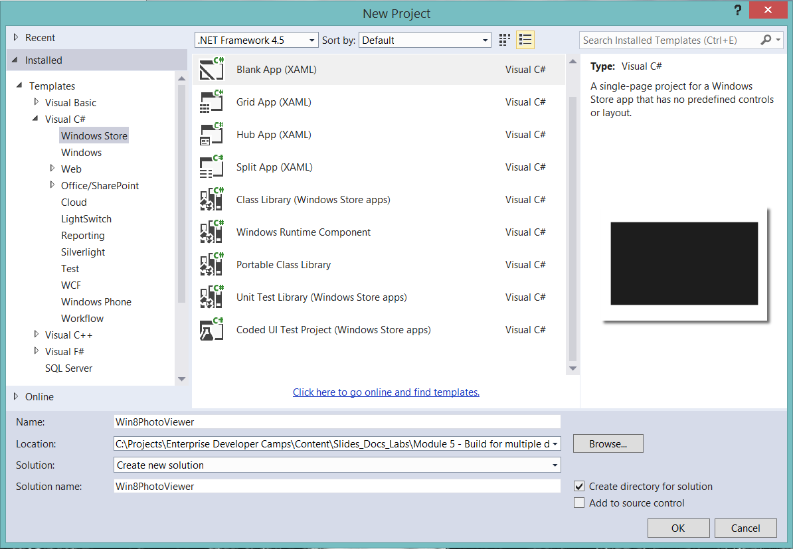

1. Right-click the **Win8PhotoViewer** project and select **Add | New Folder**. Name the folder **Models**.
2. Right-click the **Models** folder and select **Add | Class**... Name the class **Snapshot** and click **Add** to add it to the project.
3. Make the Snapshot class public and then add the following code:

public int ID { get; set; }

public string Image { get; set; }

public string Location { get; set; }

public string Comment { get; set; }

public DateTime DateTaken { get; set; }

1. Right-click the **Win8PhotoViewer** project and select **Add | New Folder**. Name the folder **Photos**.
2. Right-click the **Photos** folder and select **Add | Existing Item**... Navigate to the **Assets\Photo Viewer\Photos** folder for this module and select the images. Click **Add** to add them to the project.
3. Right-click the **Win8PhotoViewer** project and select **Add | New Folder**. Name the folder **Services**.
4. Right-click the **Services** folder and select **Add | Class**... Name the class **SnapshotService** and click **Add** to add it to the project.
5. Make the Snapshot class public and then add the following using statement:

using System.Collections.ObjectModel;

using Win8PhotoViewer.Models;

1. Add the following code:

static ObservableCollection<Snapshot> listOfSnapshots;

public SnapshotService() { }

public ObservableCollection<Snapshot> GetSnapshots()

{

listOfSnapshots = new ObservableCollection<Snapshot>();

// Add sample data at first, then use to connect

// to real data later.

listOfSnapshots.Add(new Snapshot()

{

ID = 0,

Image = "/Photos/Image1.jpg",

Comment = "Still hungry!",

DateTaken = DateTime.Now,

Location = "Marcy Mountain"

});

listOfSnapshots.Add(new Snapshot()

{

ID = 1,

Image = "/Photos/Image2.jpg",

Comment = "It took a lot of stings to get this one.",

DateTaken = DateTime.Now,

Location = "Algonquin Peak"

});

listOfSnapshots.Add(new Snapshot()

{

ID = 2,

Image = "/Photos/Image3.jpg",

Comment = "Beautiful lake view! What a great day.",

DateTaken = DateTime.Now,

Location = "Whitaker Lake"

});

listOfSnapshots.Add(new Snapshot()

{

ID = 3,

Image = "/Photos/Image4.jpg",

Comment = "A burning flower of power",

DateTaken = DateTime.Now,

Location = "Haystack"

});

listOfSnapshots.Add(new Snapshot()

{

ID = 4,

Image = "/Photos/Image5.jpg",

Comment = "Berrrrup... I can't do the voice right, you had to be there.",

DateTaken = DateTime.Now,

Location = "Skylight Molehill"

});

listOfSnapshots.Add(new Snapshot()

{

ID = 5,

Image = "/Photos/Image6.jpg",

Comment = "Lily pad with the rare Marshall flower",

DateTaken = DateTime.Now,

Location = "Whiteface Pond"

});

listOfSnapshots.Add(new Snapshot()

{

ID = 6,

Image = "/Photos/Image7.jpg",

Comment = "Never found out what kind of flower this is.",

DateTaken = DateTime.Now,

Location = "Dix Valley"

});

listOfSnapshots.Add(new Snapshot()

{

ID = 7,

Image = "/Photos/Image8.jpg",

Comment = "I totally found him this way and did not in any way pose this photo.",

DateTaken = DateTime.Now,

Location = "Gray Skies Ranch"

});

listOfSnapshots.Add(new Snapshot()

{

ID = 8,

Image = "/Photos/Image9.jpg",

Comment = "Then some sort of flying rat in a blue hat attacked me.",

DateTaken = DateTime.Now,

Location = "Iroquois Peak"

});

return listOfSnapshots;

}

public Snapshot GetSnapshot (int snapshotId)

{

Snapshot snapshot = (from _snapshot in listOfSnapshots

where _snapshot.ID == snapshotId

select _snapshot).First();

return snapshot;

}

1. Right-click the **Win8PhotoViewer** project and select **Add | New Folder**. Name the folder **ViewModels**.
2. Right-click the **ViewModels** folder and select **Add | Existing Item**... Navigate to the **Assets\Photo Viewer\Windows Store** folder for this module and select **ViewModelBase.cs**. Click **Add** to add it to the project.
3. Right-click the **ViewModels** folder and select **Add | Class**... Name the class **MainViewModel** and click **Add** to add it to the project.
4. Add the following using statements:

using System.Collections.ObjectModel;

using Win8PhotoViewer.Models;

using Win8PhotoViewer.Services;

1. Modify the class code as follows:

public class MainViewModel: ViewModelBase

{

public ObservableCollection<Snapshot> Snapshots { get; private set; }

public MainViewModel()

{

var snapShotService = new SnapshotService();

this.Snapshots = snapShotService.GetSnapshots();

}

}

1. Right-click the **ViewModels** folder and select **Add | Class**... Name the class **SnapshotViewModel** and click **Add** to add it to the project.
2. Add the following using statements:

using Win8PhotoViewer.Models;

using Win8PhotoViewer.Services;

1. Modify the class code as follows:

public class SnapshotViewModel : ViewModelBase

{

public Snapshot Snapshot { get; private set; }

public SnapshotViewModel()

{

}

public void GetSnapshot(int snapshotId)

{

var snapShotService = new SnapshotService();

this.Snapshot = snapShotService.GetSnapshot(snapshotId);

}

}

1. Delete MainPage.xaml.
2. Right-click the **Win8PhotoViewer** project and select **Add | New Item**.
3. Select the **Basic Page** template and use the **Name** **“MainPage”**. Click **Add** to create the page. Click **Yes** when you are prompted to add files. Visual Studio adds a number of files in the Common folder.

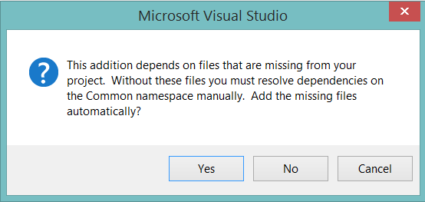

1. In the MainPage.xaml file, make the following change in bold:

<Page

x:Name="pageRoot"

x:Class="W8PhotoFeed.MainPage"

DataContext="{Binding **MainViewModel**, RelativeSource={RelativeSource Self}}"

1. Make the following change in bold:

<Page.Resources>

<x:String x:Key="AppName">**Windows 8 Snapshot Viewer**</x:String>

</Page.Resources>

1. Add the following code between the two </Grid> elements:

<ListView x:Name="SnapshotsListView"

ItemsSource="{Binding Snapshots}"

Grid.Row="1"

Margin="120,0,0,0"

SelectionChanged="SnapshotsListView_SelectionChanged">

<ListView.ItemTemplate>

<DataTemplate>

<StackPanel Margin="0,0,0,17">

<Image Source="{Binding Image}"

Height="250"

Margin="12,12,0,0"

Stretch="Uniform"

HorizontalAlignment="Left"/>

<TextBlock Text="{Binding Location}"

TextWrapping="Wrap"

Margin="12,0,0,0"/>

</StackPanel>

</DataTemplate>

</ListView.ItemTemplate>

</ListView>

1. Right-click and select **View Code**.
2. Add the following using statement:

Using Win8PhotoViewer.ViewModels;

1. Remove the following code:

private ObservableDictionary defaultViewModel = new ObservableDictionary();

/// <summary>

/// This can be changed to a strongly typed view model.

/// </summary>

public ObservableDictionary DefaultViewModel

{

get { return this.defaultViewModel; }

}

1. Replace the above code with the following:

private MainViewModel mainViewModel = new MainViewModel();

public MainViewModel MainViewModel

{

get { return this.mainViewModel; }

}

1. Press **F5** to build and run the application. You should see images. In addition, you should see counters in the upper left and right of the screen.

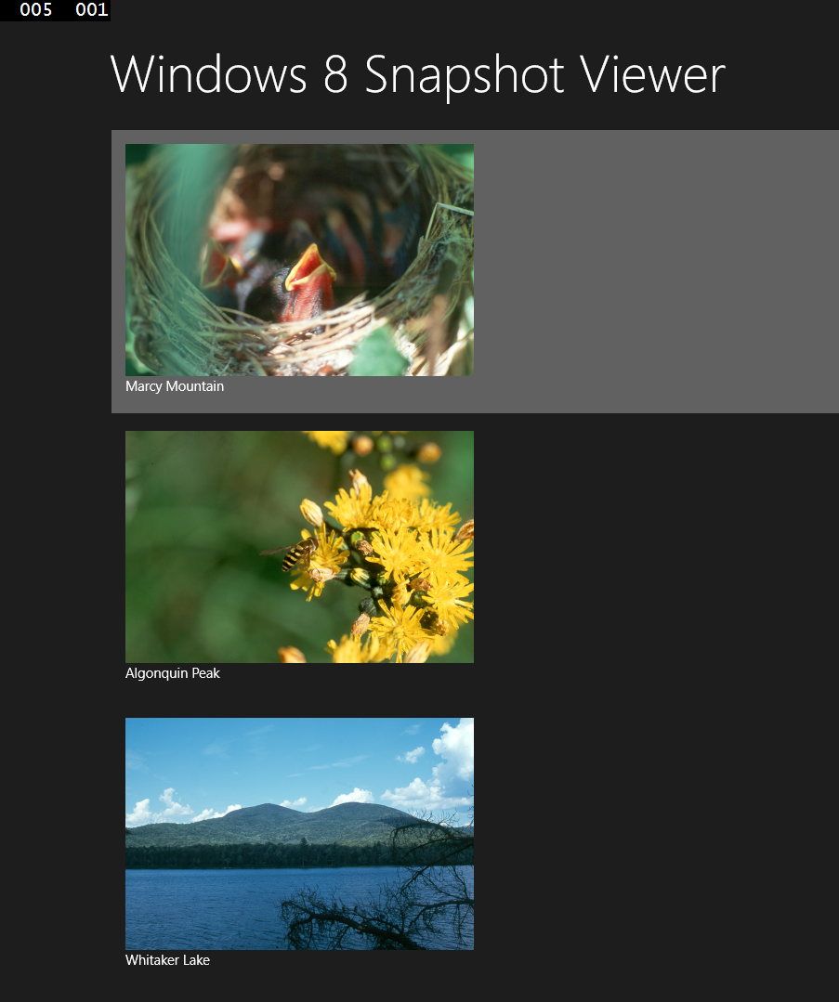

1. In Visual Studio 2013, select **Debug | Stop Debugging** from the main menu.
2. Open App.xaml.cs and comment out the following code in the **OnLaunched** method:

if (System.Diagnostics.Debugger.IsAttached)

{

this.DebugSettings.EnableFrameRateCounter = true;

}

1. Right-click the **Win8PhotoViewer** project and select **Add | New Item**.
2. Select the **Basic Page** template and use the **Name** **“SnapshotPage”**. Click **Add** to create the page.
3. In the SnapshotPage.xaml file, make the following change in bold:

<Page

x:Name="pageRoot"

x:Class="W8PhotoFeed.MainPage"

DataContext="{Binding **SnapshotViewModel**, RelativeSource={RelativeSource Self}}"

1. Add the following code in bold:

<Grid Background="{ThemeResource ApplicationPageBackgroundThemeBrush}"

**DataContext="{Binding Snapshot}"**>

1. Make the following change in bold:

<TextBlock x:Name="pageTitle" Text="**{Binding Location}**"

1. Add the following code between the two </Grid> elements:

<StackPanel Grid.Row="1"

Margin="120,0,0,0"

Orientation="Vertical">

<Image Source="{Binding Image}"

HorizontalAlignment="Left"

Height="500"

Width="750"

Stretch="Fill"/>

<TextBlock Text="{Binding Comment}"

Style="{StaticResource HeaderTextBlockStyle}"

TextWrapping="Wrap"

Margin="0,20,0,0"/>

<TextBlock Text="taken on:"

Style="{StaticResource SubtitleTextBlockStyle}"

Margin="0,10,0,0"/>

<TextBlock Text="{Binding DateTaken}"

Style="{StaticResource SubtitleTextBlockStyle}"/>

</StackPanel>

1. Right-click and select **View Code**.
2. Add the following using statement:

Using Win8PhotoViewer.ViewModels;

1. Remove the following code:

private ObservableDictionary defaultViewModel = new ObservableDictionary();

/// <summary>

/// This can be changed to a strongly typed view model.

/// </summary>

public ObservableDictionary DefaultViewModel

{

get { return this.defaultViewModel; }

}

1. Replace the above code with the following:

private SnapshotViewModel snapshotViewModel = new SnapshotViewModel ();

public SnapshotViewModel SnapshotViewModel

{

get { return this. snapshotViewModel; }

}

1. In the MainPage.xaml, add the following code to handle the SelectionChanged event when the user selects a photo to view:

<ListView x:Name="SnapshotsListView"

ItemsSource="{Binding Snapshots}"

Grid.Row="1"

Margin="120,0,0,0"

**SelectionChanged="SnapshotsListView_SelectionChanged"**>

1. Right-click on **SnapshotsListView_SelectionChanged** and select **Go To Definition**.
2. Add the following code to navigate to the Snapshot page and pass the id of the selected photo:

if (this.SnapshotsListView.SelectedItem == null)

return;

this.Frame.Navigate(typeof(SnapshotPage),

((Snapshot)SnapshotsListView.SelectedItem).ID);

1. Add the following using statement:

Using Win8PhotoViewer.Models;

1. Return to the SnapshotPage.xaml.cs file.
2. In the LoadState method, add the following code to call the GetSnapshot method of the SnapshotViewModel and pass the selected photo’s id:

snapshotViewModel.GetSnapshot(Convert.ToInt32(e.NavigationParameter));

1. Press **F5** to build and run the application. Select an image. You should see the image on a new page with additional information.



1. In Visual Studio 2013, select **Debug | Stop Debugging** from the main menu.

### Task 2: Build a Windows Phone app

In this task, we’ll build a Windows Phone version of the photo viewer app.

1. Open Visual Studio 2013.
2. Select **File | New | Project…** from the main menu.
3. From the **Templates** list on the left side, select **Visual C# | Windows Phone**. Select the W**indows Phone App** template and use the **Name** **“WinPhonePhotoViewer”**. Click **OK** to create the project.

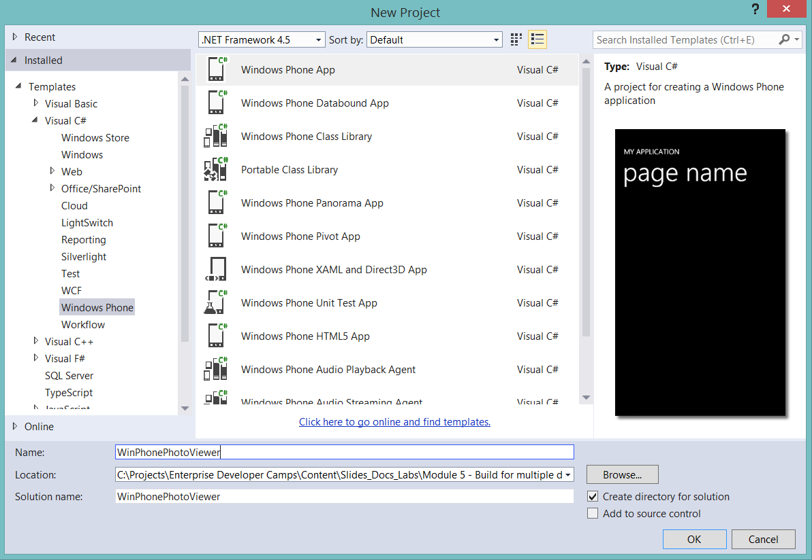

1. Right-click the **WinPhonePhotoViewer** project and select **Add | New Folder**. Name the folder **Models**.
2. Right-click the **Models** folder and select **Add | Class**... Name the class **Snapshot** and click **Add** to add it to the project.
3. Make the Snapshot class public and then add the following code:

public int ID { get; set; }

public string Image { get; set; }

public string Location { get; set; }

public string Comment { get; set; }

public DateTime DateTaken { get; set; }

1. Right-click the **WinPhonePhotoViewer** project and select **Add | New Folder**. Name the folder **Photos**.
2. Right-click the **Photos** folder and select **Add | Existing Item**... Navigate to the **Assets\Photo Viewer\Photos** folder for this module and select the images. Click **Add** to add them to the project.
3. Right-click the **WinPhonePhotoViewer** project and select **Add | New Folder**. Name the folder **Services**.
4. Right-click the **Services** folder and select **Add | Class**... Name the class **SnapshotService** and click **Add** to add it to the project.
5. Make the Snapshot class public and then add the following using statement:

using System.Collections.ObjectModel;

using Win8PhotoViewer.Models;

1. Add the following code:

static ObservableCollection<Snapshot> listOfSnapshots;

public SnapshotService() { }

public ObservableCollection<Snapshot> GetSnapshots()

{

listOfSnapshots = new ObservableCollection<Snapshot>();

// Add sample data at first, then use to connect

// to real data later.

listOfSnapshots.Add(new Snapshot()

{

ID = 0,

Image = "/Photos/Image1.jpg",

Comment = "Still hungry!",

DateTaken = DateTime.Now,

Location = "Marcy Mountain"

});

listOfSnapshots.Add(new Snapshot()

{

ID = 1,

Image = "/Photos/Image2.jpg",

Comment = "It took a lot of stings to get this one.",

DateTaken = DateTime.Now,

Location = "Algonquin Peak"

});

listOfSnapshots.Add(new Snapshot()

{

ID = 2,

Image = "/Photos/Image3.jpg",

Comment = "Beautiful lake view! What a great day.",

DateTaken = DateTime.Now,

Location = "Whitaker Lake"

});

listOfSnapshots.Add(new Snapshot()

{

ID = 3,

Image = "/Photos/Image4.jpg",

Comment = "A burning flower of power",

DateTaken = DateTime.Now,

Location = "Haystack"

});

listOfSnapshots.Add(new Snapshot()

{

ID = 4,

Image = "/Photos/Image5.jpg",

Comment = "Berrrrup... I can't do the voice right, you had to be there.",

DateTaken = DateTime.Now,

Location = "Skylight Molehill"

});

listOfSnapshots.Add(new Snapshot()

{

ID = 5,

Image = "/Photos/Image6.jpg",

Comment = "Lily pad with the rare Marshall flower",

DateTaken = DateTime.Now,

Location = "Whiteface Pond"

});

listOfSnapshots.Add(new Snapshot()

{

ID = 6,

Image = "/Photos/Image7.jpg",

Comment = "Never found out what kind of flower this is.",

DateTaken = DateTime.Now,

Location = "Dix Valley"

});

listOfSnapshots.Add(new Snapshot()

{

ID = 7,

Image = "/Photos/Image8.jpg",

Comment = "I totally found him this way and did not in any way pose this photo.",

DateTaken = DateTime.Now,

Location = "Gray Skies Ranch"

});

listOfSnapshots.Add(new Snapshot()

{

ID = 8,

Image = "/Photos/Image9.jpg",

Comment = "Then some sort of flying rat in a blue hat attacked me.",

DateTaken = DateTime.Now,

Location = "Iroquois Peak"

});

return listOfSnapshots;

}

public Snapshot GetSnapshot (int snapshotId)

{

Snapshot snapshot = (from _snapshot in listOfSnapshots

where _snapshot.ID == snapshotId

select _snapshot).First();

return snapshot;

}

1. Right-click the **WinPhonePhotoViewer** project and select **Add | New Folder**. Name the folder **ViewModels**.
2. Right-click the **ViewModels** folder and select **Add | Existing Item**... Navigate to the **Assets\Photo Viewer\Windows Phone** folder for this module and select **ViewModelBase.cs**. Click **Add** to add it to the project.
3. Right-click the **ViewModels** folder and select **Add | Class**... Name the class **MainViewModel** and click **Add** to add it to the project.
4. Add the following using statements:

using System.Collections.ObjectModel;

using WinPhonePhotoViewer.Models;

using WinPhonePhotoViewer.Services;

1. Modify the class code as follows:

public class MainViewModel: ViewModelBase

{

public ObservableCollection<Snapshot> Snapshots { get; private set; }

public MainViewModel()

{

var snapShotService = new SnapshotService();

this.Snapshots = snapShotService.GetSnapshots();

}

}

1. Right-click the **ViewModels** folder and select **Add | Class**... Name the class **SnapshotViewModel** and click **Add** to add it to the project.
2. Add the following using statements:

using WinPhonePhotoViewer.Models;

using WinPhonePhotoViewer.Services;

1. Modify the class code as follows:

public class SnapshotViewModel : ViewModelBase

{

public Snapshot Snapshot { get; private set; }

public SnapshotViewModel()

{

}

public void GetSnapshot(int snapshotId)

{

var snapShotService = new SnapshotService();

this.Snapshot = snapShotService.GetSnapshot(snapshotId);

}

}

1. Delete MainPage.xaml.
2. Right-click the **WinPhonePhotoViewer** project and select **Add | New Item**.
3. Select the **Windows Phone Portrait Page** template in the Windows Phone section and use the **Name** **“MainPage”**. Click **Add** to create the page.
4. In the MainPage.xaml file, add the following code in bold:

<phone:PhoneApplicationPage

x:Class="WPPhotoFeed.MainPage"

**DataContext="{Binding MainViewModel, RelativeSource={RelativeSource Self}}"**

1. Make the following changes in bold:

<StackPanel x:Name="TitlePanel" Grid.Row="0" Margin="12,17,0,28">

<TextBlock Text="**Windows Phone Photo Feed**"

Style="{StaticResource PhoneTextNormalStyle}"

Margin="12,0"/>

<TextBlock Text="**Snapshots**" Margin="9,-7,0,0"

Style="{StaticResource PhoneTextTitle1Style}"/>

</StackPanel>

1. Add the following code to the ContentPanel Grid:

<phone:LongListSelector x:Name="SnapshotLongListSelector"

Margin="0,0,-12,0"

ItemsSource="{Binding Snapshots}">

<phone:LongListSelector.ItemTemplate>

<DataTemplate>

<StackPanel Margin="0,0,0,17">

<Image Source="{Binding Image}"

Height="250"

Margin="12,12,0,0"

Stretch="Uniform"

HorizontalAlignment="Left"/>

<TextBlock Text="{Binding Location}"

TextWrapping="Wrap"

Style="{StaticResource PhoneTextExtraLargeStyle}"/>

</StackPanel>

</DataTemplate>

</phone:LongListSelector.ItemTemplate>

</phone:LongListSelector>

1. Right-click and select **View Code**.
2. Add the following using statement:

Using WinPhonePhotoViewer.ViewModels;

1. Add the following code to the MainPage class:

private MainViewModel mainViewModel = new MainViewModel();

public MainViewModel MainViewModel

{

get { return this.mainViewModel; }

}

1. Press **F5** to build and start the Widows Phone emulator and run the application. You should see images and you should able to scroll down to see more images.

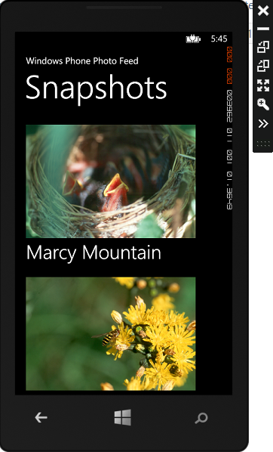

1. In Visual Studio 2013, select **Debug | Stop Debugging** from the main menu.
2. Right-click the **WinPhonePhotoViewer** project and select **Add | New Item**.
3. Select the **Windows Phone Portrait Page** template in the Windows Phone section and use the **Name** **“SnapshotPage”**. Click **Add** to create the page.
4. In the SnapshotPage.xaml file, make the following change in bold:

<phone:PhoneApplicationPage

x:Class="WPPhotoFeed.SnapshotPage"

**DataContext="{Binding SnapshotViewModel, RelativeSource={RelativeSource Self}}"**

1. Make the following change in bold:

<Grid x:Name="LayoutRoot"

Background="Transparent"

**DataContext="{Binding Snapshot}"**>

1. Make the following changes in bold:

<StackPanel x:Name="TitlePanel" Grid.Row="0" Margin="12,17,0,28">

<TextBlock Text="**Windows Phone Photo Feed**"

Style="{StaticResource PhoneTextNormalStyle}"/>

<TextBlock Text="**{Binding Location}**"

Margin="9,-7,0,0"

Style="{StaticResource PhoneTextTitle1Style}"/></StackPanel>

1. Replace the ContentPanel Grid with the following code:

<ScrollViewer Grid.Row="1"

Margin="12,0,12,0">

<StackPanel >

<Image Source="{Binding Image}"

Margin="12,0" />

<TextBlock Text="{Binding Comment}"

Style="{StaticResource PhoneTextLargeStyle}"

TextWrapping="Wrap"/>

<TextBlock Text="taken on:"

Style="{StaticResource PhoneTextNormalStyle}"/>

<TextBlock Text="{Binding DateTaken, StringFormat=\{0:f\}}"

Style="{StaticResource PhoneTextNormalStyle}"/>

</StackPanel>

</ScrollViewer>

1. Right-click and select **View Code**.
2. Add the following using statement:

Using WinPhonePhotoViewer.ViewModels;

1. Add the following code to the SnapshotPage class:

private SnapshotViewModel snapshotViewModel = new SnapshotViewModel ();

public SnapshotViewModel SnapshotViewModel

{

get { return this. snapshotViewModel; }

}

1. In the MainPage.xaml, add the following code to handle the SelectionChanged event when the user selects a photo to view:

<phone:LongListSelector x:Name="SnapshotLongListSelector"

Margin="0,0,-12,0"

ItemsSource="{Binding Snapshots}"

**SelectionChanged=**

**"SnapshotLongListSelector_SelectionChanged"**>

1. Right-click on **SnapshotsLongListSelector_SelectionChanged** and select **Go To Definition**.
2. Add the following code to navigate to the Snapshot page and pass the id of the selected photo:

NavigationService.Navigate(new Uri(

"SnapshotPage.xaml?snapshotId=" +

(SnapsnotLongListSelector.SelectedItem as Snapshot).ID,

UriKind.Relative));

1. Add the following using statement:

Using WinPhonePhotoViewer.Models;

1. Return to the SnapshotPage.xaml.cs file.
2. Add the following code to call the GetSnapshot method of the SnapshotViewModel and pass the selected photo’s id:

protected override void OnNavigatedTo(NavigationEventArgs e)

{

string selectedIndex = "";

if (NavigationContext.QueryString.TryGetValue("snapshotId", out selectedIndex))

{

int snapshotId = int.Parse(selectedIndex);

snapshotViewModel.GetSnapshot(Convert.ToInt32(snapshotId));

}

}

1. Press **F5** to build and run the application. Select an image. You should see the image on a new page with additional information.

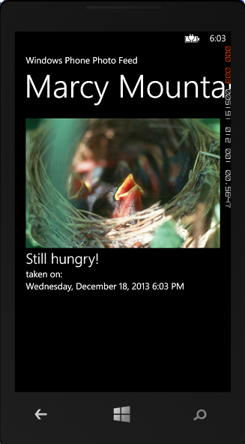

1. In Visual Studio 2013, select **Debug | Stop Debugging** from the main menu.

### Task 3: Use a Portable Class Library

As you built each of the two apps, you noticed that a lot of the code is the same in both projects. In this task, we’ll create a portable class library that will contain that shared code. We’ll then modify both the Windows Store and Windows Phone apps to use the portable class library.

1. Open Visual Studio 2013.
2. Select **File | New | Project…** from the main menu.
3. From the **Templates** list on the left side, select **Visual C#**. Select the **Portable Class Library** template and use the **Name** **“PhotoViewerPCL”**. Click **OK** to create the project.

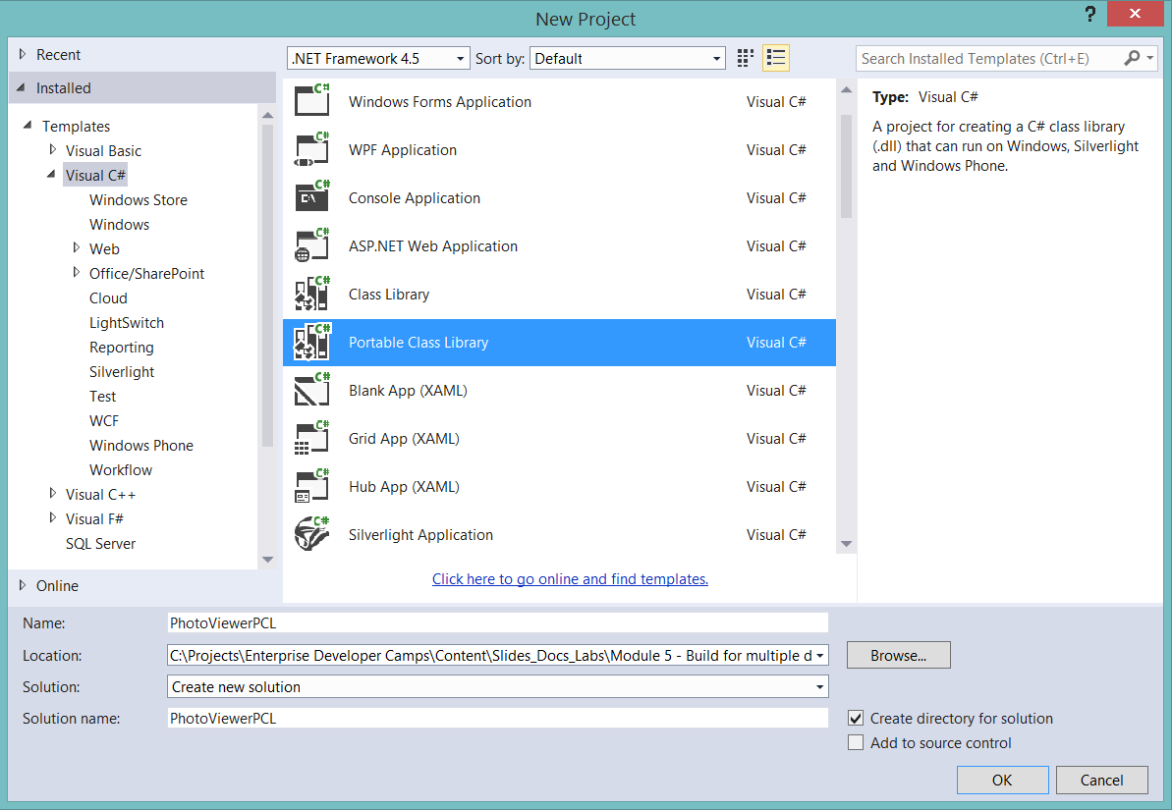

1. Accept the default target frameworks and click **OK**.

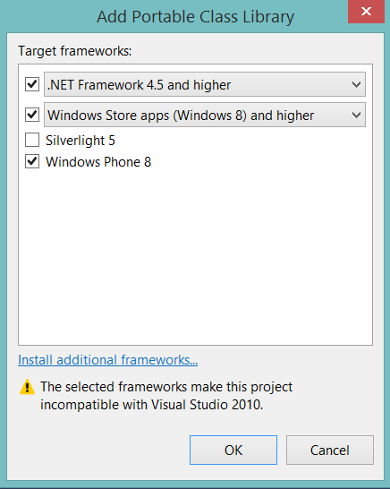

1. Delete **Class1.cs**.
2. Right-click the **PhotoViewerPCL** project and select **Add | New Folder**. Name the folder **Models**.
3. Right-click the **Models** folder and select **Add | Existing Item**... Navigate to the Models folder of either the Windows Store or Windows Phone photo viewer project. Select **Snapshot.cs** and click **Add** to add it to the project.
4. Right-click the **PhotoViewerPCL** project and select **Add | New Folder**. Name the folder **Services**.
5. Right-click the **Services** folder and select **Add | Existing Item**... Navigate to the Services folder of either the Windows Store or Windows Phone photo viewer project. Select **SnapshotService.cs** and click **Add** to add it to the project.
6. Right-click the **PhotoViewerPCL** project and select **Add | New Folder**. Name the folder **ViewModels**.
7. Right-click the **ViewModels** folder and select **Add | Existing Item**... Navigate to the ViewModels folder of either the Windows Store or Windows Phone photo viewer project. Select **MainViewModel.cs**, **SnapshotViewModel.cs** and **ViewModelBase.cs** and click **Add** to add them to the project.
8. Open any of the files you just added. Right-click on **Win8PhotoViewer** or **WinPhonePhotoViewer** and select **Refactor | Rename**. Set the **New name** to **PhotoViewerPCL** and click **OK**.
9. Build the solution to confirm you changed the namespaces.
10. Open the **Win8PhotoViewer** solution.
11. Right-click the **References** node in the **Solution Explorer** and select **Add Reference…**.
12. Select **Browse** from the left list and click the **Browse…** button in the bottom right corner to select assemblies to add.
13. Navigate to the **bin\Debug** folder of the **PhotoViewerPCL** project. Select **PhotoViewerPCL.dll**. Click **Add** to add the reference to the project.
14. Click **OK** to close the **Reference Manager** dialog.
15. Delete the **Models**, **Services** and **ViewModels** folders. The code in these files is contained in the portable class library.
16. Open **MainPage.xaml.cs**.
17. Make the following changes in bold:

using **PhotoViewerPCL**.ViewModels;

using **PhotoViewerPCL**.Models;

1. Open **SnapshotPage.xaml.cs**.
2. Make the following change in bold:

using **PhotoViewerPCL**.ViewModels;

1. Press **F5** to build and run the application. The app should behave as it did before. You should be able to view images on the main page and then select an image to view it in more detail.
2. In Visual Studio 2013, select **Debug | Stop Debugging** from the main menu.
3. Open the **WinPhonePhotoViewer** solution.
4. Right-click the **References** node in the **Solution Explorer** and select **Add Reference…**.
5. Select **Browse** from the left list and click the **Browse…** button in the bottom right corner to select assemblies to add.
6. Navigate to the **bin\Debug** folder of the **PhotoViewerPCL** project. Select **PhotoViewerPCL.dll**. Click **Add** to add the reference to the project.
7. Click **OK** to close the **Reference Manager** dialog.
8. Delete the **Models**, **Services** and **ViewModels** folders. The code in these files is contained in the portable class library.
9. Open **MainPage.xaml.cs**.
10. Make the following changes in bold:

using **PhotoViewerPCL**.ViewModels;

using **PhotoViewerPCL**.Models;

1. Open **SnapshotPage.xaml.cs**.
2. Make the following change in bold:

using **PhotoViewerPCL**.ViewModels;

1. Press **F5** to build and run the application. The app should behave as it did before. You should be able to view images on the main page and then select an image to view it in more detail.
2. In Visual Studio 2013, select **Debug | Stop Debugging** from the main menu.